Beaconhouse School System-Jubilee Capmus Karachi
2014
The Story of Karachi A Walk in the Town

Shaista Khurshid
Project file for hartmut kerutzer

EARLY HISTORY

The earliest account of the area where Karachi is located can be found in the record books of one of Alexander-the-Great's admirals, who sailed back home from the Greek expedition to India, from a harbor by the Indus delta, known as Krokola. According to widely held belief though, the city of Karachi started its life as a small fishing settlement by the Indus Delta known as Kolachi-jo-Kun (the ditch of Kolachi), named after an old fisherwoman, Mai Kolachee who took up settlement here.
In time, the settlement grew into a small fishing village and came to be known as Kolachi-jo-Goth or, the village of Kolachee. This small fishing village gradually started trading activities by sea with Muscat and Bahrain.
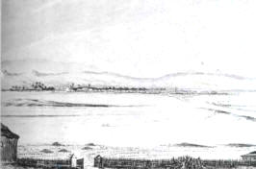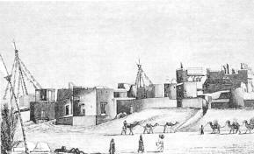
Views of the old village of Karachi (c. 1850)

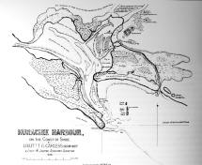
An early map of the Karachi harbor (Carless, 1838)
KARACHI's EARLY DEVELOPMENT

The British recognized the importance of this natural harbor by the Indus and started developing the fishing village as a principal port for the Indus River basin. In 1843, a river steamer service was introduced linking Karachi with the city of Multan, 500 miles upstream on the Indus. The population of the city started rising rapidly and by the 1850's, Karachi had become an established city with a population of about 14,000 and prosperous overseas trade.
MODERN KARACHI

While the inner and historic core city of Karachi has dilapidated and decayed beyond recognition, losing its former glory and splendour, Karachi overall as a port city, has turned out to be a fine city with great economic prospects. Presently Karachi is a bustling port city of about 14 million people and is the financial and industrial center of Pakistan's economy. The city has very modern port facilities that handle the bulk of the trade of Pakistan and the landlocked Central Asian countries. This city of ample sunshine and cool sea breezes is also the melting pot of Pakistan where people from all provinces come to make a living. There was a brief period where violence dominated the life of Karachi, but like any other great city, this transition period has taken a back seat to opening new horizons and new prospects for this ever-expanding, ever-evolving city.
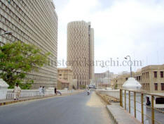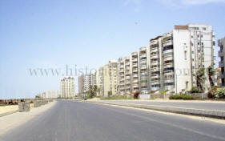
Habib Bank Plaza Clifton

MAP OF KARACHI CITY

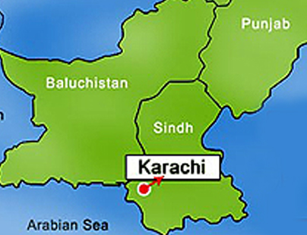

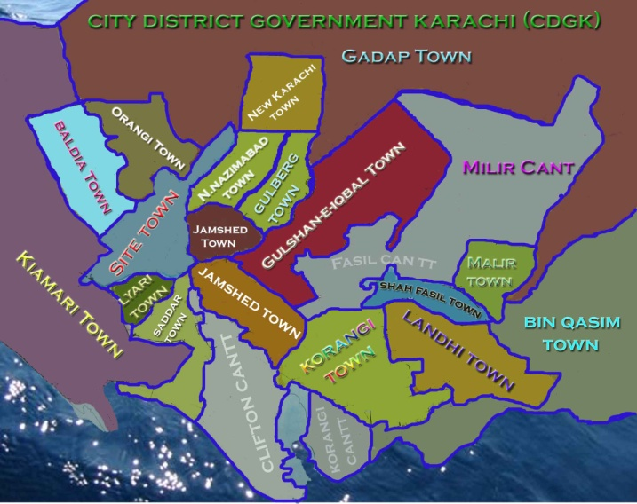
AREA AND POPULATION
From a medium-size city of less than 500,000 population in 1947 it grew to well over five million in 1981 and, according to most conservative estimates, has now exceeded 14 million mark. The area of Karcahi divison is about 3,366 sq. km with more than 18 towns and 6 cantonment boards.
CLIMATE
Karachi is located on semi-arid zone but due to marine affects, it enjoys a moderate climate. May and June are hottest months of the year with temperature as high as 43.3 degree centigrade while January is the coldest month with temperature as low as 5 degree centigrade. The mean annual rainfall is about 7 inches.
City Aerial View

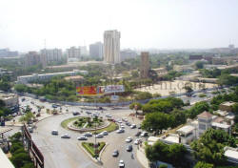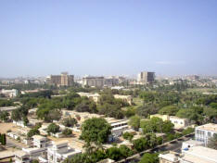

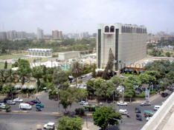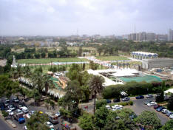
ATTRACTIONS
Karachi is a city that has a large variety of places to go and things to do. In every part of the city there is some club or organization. No matter where you are, you can be guaranteed a good time.

. | Some of the attractions you will enjoy are handicrafts, particularly rugs and carpets of rare design and beauty, produced by talented artisans. You will find extensive range of restaurants feature cuisine from world over, clean and golden beaches, Theme parks, Zoo, Country & Water parks, Ship breaking tours and many more.  Karachi is a shoppers paradise. If you have the power to purchase you can get finest products at the most reasonable prices in Karachi. Crockery, furniture, paintings, crystal works, marble products, steel goods, classical stitched clothing, glassware, automobile, watches, best textile products and much more.  Historical Architecture: There are many historical buildings in Karachi. To name few, some are like Tomb of Quaid-e-Azam, City Courts, The Empress Market, Liaquat National Library, Karachi Port Trust, Sindh assembly buildings, Sindh Madressah-ul-Islam and Wazir Mansion (Home of Quaid-e-Azam).  Other renowned places are like Habib Bank Plaza, MCB Tower, PSO building, Avari Towers. Habib Bank Plaza is the tallest building of the city and the country.  EDUCATION  Karachi is also famous for its educational network. There are a number of schools, colleges and institutes imparting education in the fields of science, arts, engineering and information technology. Many universities main campuses resides in Karachi. It also host number of international university campuses and attracts many overseas students.  Some of the well-known universities and institutes include Karachi University, Agha Khan University, NED University, Baqai Medical University, National University, Hamdard University, IBA, Sir Syed University and many more.  INDUSTRY  The most of the major banks, financial institutions, insurance companies, corporate houses are based in Karachi. The Industrial areas of the city are SITE, Landhi, Korangi and New Karachi where enormous small, medium and large industrial units are located. Their entire managerial and financial activities are routed through this city. The presence of central bank's head offices is the manifestation of it.  IMPORTANT PLACES  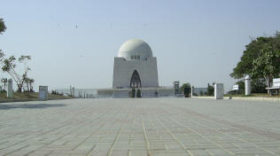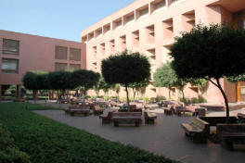  Mausoleum of Quaid-e-Azam The Aga Khan Medical University  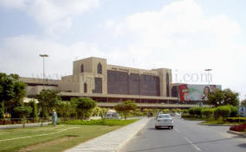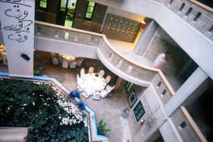  The Jinnah International Airport The Indus Valley School of Art  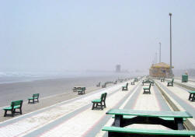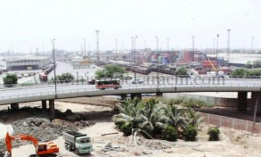  The Clifton Beach The Portside  Educatio

