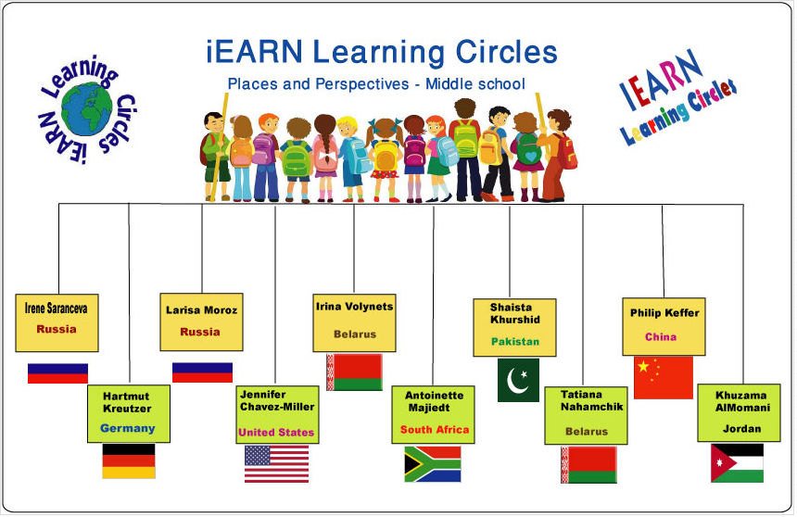
Project Idea
Learning Circle Group: Places & Perspectives middle school Sponsoring Teacher: Elena Golub, Nina Bobrova, Irene Saranceva.
Sponsor School: Lyceum of Natural Science (LYNS)
City: Saratov
Country: Russia
Name of Project: Places for Students to Spend Their Free Time
Goal of the Project: To know more about cultural and social life of the communities, through the places our students and other teens can visit to enjoy themselves (theatres, cinemas, aqua parks, parks, etc.), about some religious studies and places for kids – if any are visited by your students.
Type Of Writing Requested: you can use docs, video, PDF, ppt .. etc.
Description Of What You Are Looking For From Other Schools:
- Tell us about the cinemas, clubs, theatres, cafes in your community teens (your students) can go to with the parents or with friends
- Name the most important ones (pictures if available).
- The role (if any) of religion and religious studies in your students’ life and any place(s) in your city connected with religion in case your students are into it.

Questions:
What is the way and places for your students to “edutain” (rather than to entertain) themselves together with their friends/relatives?
If any of your kids are into religion, then what role does it play in their life and what are the places connected with it?
Story Prompts: community theatres, parks, etc.
Detailed Instructions for Collecting Information: the internet, your camera, interviews with classmates, with other people.
Ideal Number Of Submissions From Each School: 1 or 2 files
Preferred Length Of Articles: 2 to 6 pages of word.doc or 6-8 slides of ppt.
Deadline for Receiving Information 14th April (Circle deadline is April 20, 2014):
