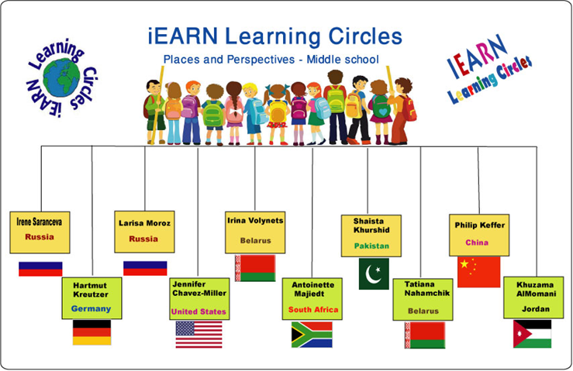

Learning Circle Group: Places & Perspectives middle school – PPM1
Sponsoring Teacher: Larisa Moroz
Sponsor School: Educational centre №1497
City: Moscow
Country: Russia
Name of the PROJECT: “Attractions(monuments) in my home town(area) are designated by UNESCO as World Heritage”
Project Goal: to learn more about World Heritage objects in other countries
Type of Writing Requested: word document, Power Point Presentation, video
Description of What You Are Looking for from Other Schools:
Other schools should find information about World Heritage objects in their area to make a list of such objects to be in touch with the great number of them;
Also students maybe find interesting, curious stories connected with these objects; write (with photos) or make a presentation.
Ideal Number of Submissions from each school: 1-3;
Preferred Length of Article: not more than 5 slides for each object or 1 page of word document for each object.
Deadline For Receiving Information: April 15, 2014

