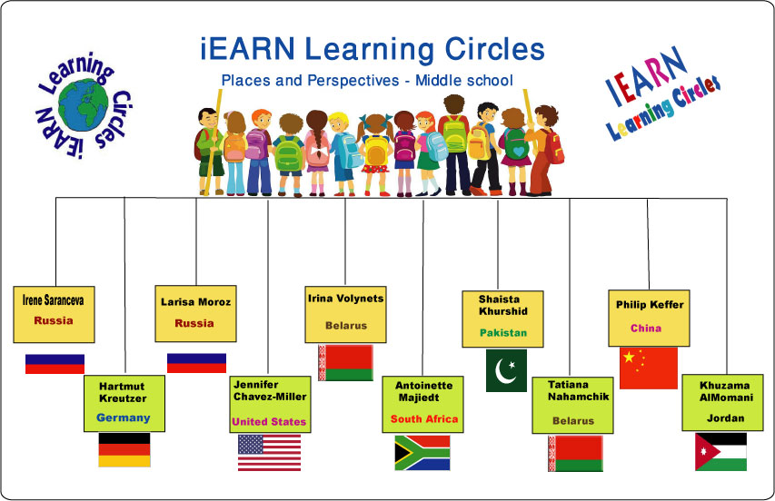
Project Idea
Learning Circle Group: Places & Perspectives middle school – PPM1
Sponsoring Teacher: Tatiana Nahamchik
Sponsor School: Gymnasium 1
City: Cherven
Country: Belarus
Name of the PROJECT: "Fun in my Native City" / "Golden Ring"
Tourism development has a stimulating effect on economic sectors such as transport, communications, trade , construction, agriculture , consumer goods , and is one of the most promising areas of economic restructuring.
As a rule, any tourist trip needs entertainment. People hit the road for a new unforgettable impressions, thrill and positive emotions.
Offering such a topic, we would like to explore the famous entertainment tourism objects closer. And consequently, develop a tour of entertainment tourism.
Project Goal: Investigate the places of entertainment of the area to attract tourists and the opportunity to develop different tourist routs
Type of Writing Requested: word document, presentation (ppt, prezi), video
Description of What You Are Looking for from Other Schools:
- conduct a survey of the most exciting entertainment centers in the region
- according to the results of the survey a list of places of entertainment (2 to 9) should be done
- develop the route of entertainment tourism objects in your region
- describe in detail why they may be interesting for tourists
- just write, make a presentation or a short video (film) about them.
Ideal Number of Submissions from Each School: 1-2;
Preferred Length of Articles: 10-20 slides for presentation, 1-5 pages for word documents.
Deadline For Receiving Information: April 15,2014 (Circle deadline is April 20, 2013)

